PartCover Browser
This application is GUI wrapper over PartCover.exe (console version). Here we’ll try describe common abilities of PartCover Browser.

Main Dialog
See at the screenshot.
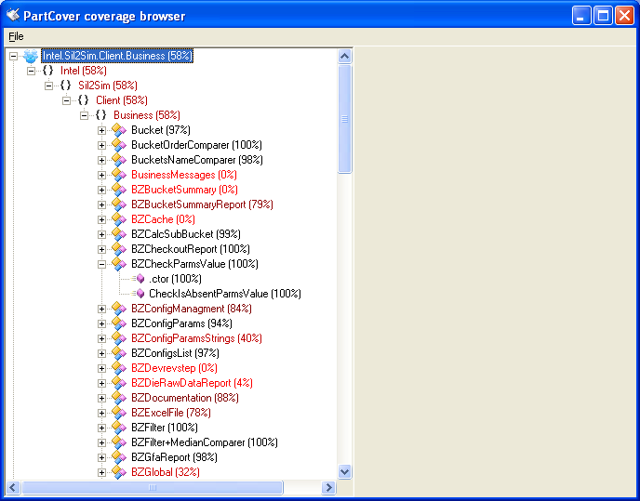

You see application main form.
In main menu you can see following options:
- Exit. This option closes application.
- Run Target. Through this option you can start target application and get the report
- Open Report. Opens report saved earlier.
- Save Report As. Save current report. If you have no report opened – nothing will be happen.

Run Target Dialog
In this dialog you can set options for PartCover driver to make coverage report. You can read “PartCover Console Manual” to get imagination about options that can be set here.
Anyway, here is another way to set rules for report. You can write your rules in “Rules” text box, putting line break after each rule. If you want to include rule into the report – place a “+” sign right before rule start. If you want to include rule into the report – place a “-” sign. Look at the example screen shot.
Also you can save you settings entered or load settings saved earlier.
After you press “Start” button, report will be generated and loaded into browser.
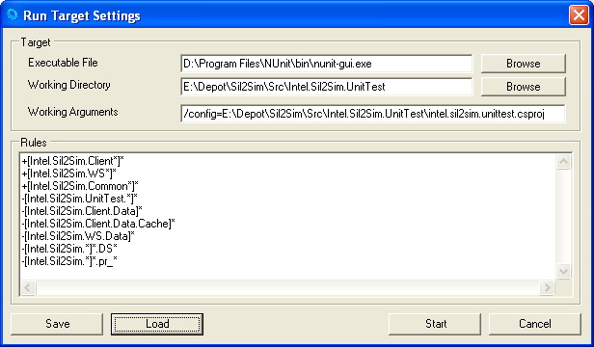

Contact Information
If you have any bug report or suggestion how to improve application, or you have any things that you’d like to see in application, you are always welcome at my e-mail. And place a “PartCover” into mail subject. Good luck!

Name: Loginov Oleg (aka Oregu)
Email: oregu@yandex.ru

